CSE 414 HW6

YANG ZHANG

1030416

Q1

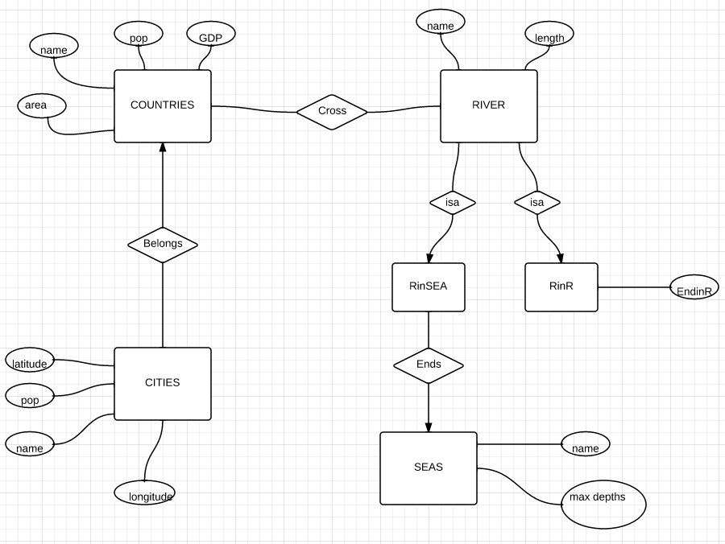

Q2

create table InsuranceCo (

name text primary key,

phone int);

create table Vehicle(

licencePlate text primary key,

year int, cname text references InsuranceCo(name),

maxLiabitlity text, maxLossDamage text, pssn int references Person(ssn));

create table Car(

cplate text references Vehicle(licencePlate),

make text);

create table Truck(

tplate text references Vehicle(licencePlate),

capacity text,

tlicence int references ProfessionalDriver(licenceNo));

create table Person(

ssn int primary key,

name text);

create table Driver(

licenceNo int primary key, dssn int references Person(ssn));

create table ProfessionalDriver(licenceNos int references Driver(licenceNo),

medicalHistory text);

create table NonProfessionalDriver(licenceNos int references Driver(licenceNo));

create table Drivers(licenceNo int primary key, plate references Vehicle(licencePlate));

Q3

i. R(A,B,C,D,E) FD: D -> B, CE -> A

step 1: D+ =DB decompose into R1(D,B), R2(D,C,E,A) since R1 is in BCNF continue to decompose R2

step 2: CE+ =CEA decompose R2 into R3(CED) and R4(CE, A)

ii. S(A,B,C,D,E) FD: A -> E, BC -> A, DE -> B

step 1: A+ = AE decompose into S1(A,E), S2(A,B,C,D) since S1 is in BCNF continue to decompose S2

step 2: BC+ =BCA decompose S2 into S3(BC,A), S3(BCD)

Q4

a. FD: NONE

b. FD: A->B, B->C, C->D, D->A

c. FD: A -> B, B -> A, C->D, D->C, D->A

Q5

PART II

Potential FD to check:

1. YES, month -> discount

query: select count(\*) fd from (select \* from sales group by month, discount) group by month having fd >1;

this FD is holded since the checking query has no results.

2. YES, name -> price

query: select count(\*) fd from (select \* from sales group by price, discount, name) group by name, discount having fd >1;

this FD is hold since the checking query has no result.

PART III

create table priceLog(name text primary key, price int);

create table salesLog(month text primary key, discount text);

create table sub(month text, name text, primary key(month, month));

PART IV

TABLE priceLog:

create table priceLog(name text primary key, price int);

INSERT INTO priceLog(name,price) select distinct name, price from sales;

contents:

name|price

bar1|19

bar8|19

gizmo3|19

gizmo7|19

mouse1|19

gizmo6|29

gizmo4|29

mouse3|29

mouse7|29

bar4|29

bar7|29

click7|29

bar9|39

click1|39

click2|39

click3|39

click8|39

click4|49

click9|49

gizmo1|49

mouse2|49

mouse8|59

bar2|59

bar3|59

mouse9|69

mouse4|69

gizmo9|79

gizmo5|79

gizmo8|89

mouse5|89

click6|89

bar5|89

bar6|99

mouse6|99

click5|99

gizmo2|99

TABLE salesLog:

create table salesLog(month text primary key, discount text);

INSERT INTO salesLog(month,discount) select distinct month, discount from sales;

contents:

month|discount

apr|15%

aug|15%

dec|33%

feb|10%

jan|33%

jul|33%

jun|10%

mar|15%

may|10%

nov|15%

oct|10%

sep|15%

TABLE sub:

create table sub(month text references salesLog(month), name text references priceLog(name), primary key(month, name));

INSERT INTO sub(month,name) select distinct month, name from sales;

contents:

month|name

apr|bar1

apr|bar8

apr|gizmo3

apr|gizmo7

apr|mouse1

aug|bar1

aug|bar8

aug|gizmo3

aug|gizmo7

aug|mouse1

dec|bar1

dec|bar8

dec|gizmo3

dec|gizmo7

dec|mouse1

feb|bar1

feb|bar8

feb|gizmo3

feb|gizmo7

feb|mouse1

jan|bar1

jan|bar8

jan|gizmo3

jan|gizmo7

jul|bar1

jul|bar8

jul|gizmo3

jul|gizmo7

jul|mouse1

jun|bar1

jun|bar8

jun|gizmo3

jun|gizmo7

jun|mouse1

mar|bar1

mar|bar8

mar|gizmo3

mar|gizmo7

mar|mouse1

may|bar1

may|bar8

may|gizmo3

may|gizmo7

may|mouse1

nov|bar1

nov|bar8

nov|gizmo3

nov|gizmo7

nov|mouse1

oct|bar1

oct|bar8

oct|gizmo3

oct|gizmo7

oct|mouse1

sep|bar1

sep|bar8

sep|gizmo3

sep|gizmo7

sep|mouse1

sep|gizmo6

sep|gizmo4

sep|mouse3

sep|mouse7

oct|mouse7

sep|bar4

sep|bar7

sep|click7

oct|gizmo6

oct|mouse3

oct|gizmo4

oct|click7

oct|bar4

oct|bar7

nov|mouse7

nov|mouse3

nov|gizmo6

nov|gizmo4

nov|bar4

nov|bar7

nov|click7

may|mouse7

may|gizmo6

may|mouse3

may|gizmo4

may|click7

may|bar4

may|bar7

mar|mouse7

mar|mouse3

mar|gizmo6

mar|gizmo4

jun|mouse7

mar|bar4

mar|bar7

mar|click7

jun|gizmo6

jun|mouse3

jun|gizmo4

jun|click7

jun|bar4

jun|bar7

jul|mouse7

jul|mouse3

jul|gizmo6

jul|gizmo4

jul|bar4

jul|bar7

jul|click7

jan|mouse7

jan|mouse3

jan|gizmo4

jan|gizmo6

jan|click7

jan|bar4

jan|bar7

feb|mouse7

feb|mouse3

feb|gizmo4

feb|gizmo6

feb|click7

dec|mouse7

feb|bar7

dec|mouse3

dec|gizmo4

dec|gizmo6

dec|bar7

dec|click7

dec|bar4

aug|mouse7

aug|mouse3

aug|gizmo6

aug|gizmo4

aug|bar7

aug|click7

aug|bar4

apr|mouse7

apr|gizmo6

apr|mouse3

apr|gizmo4

apr|bar7

apr|click7

apr|bar4

apr|bar9

apr|click1

apr|click2

apr|click3

apr|click8

aug|click8

aug|bar9

aug|click2

aug|click3

dec|bar9

dec|click1

dec|click2

dec|click3

dec|click8

feb|click8

feb|bar9

feb|click1

feb|click2

feb|click3

jan|bar9

jan|click1

jan|click2

jan|click3

jan|click8

jul|bar9

jul|click1

jul|click2

jul|click8

jun|bar9

jun|click1

jun|click2

jun|click3

jun|click8

mar|click8

mar|bar9

mar|click1

mar|click2

mar|click3

may|bar9

may|click1

may|click2

may|click3

may|click8

nov|bar9

nov|click1

nov|click2

nov|click3

nov|click8

oct|bar9

oct|click1

oct|click2

oct|click3

oct|click8

sep|click8

sep|bar9

sep|click1

sep|click2

sep|click3

sep|click4

sep|click9

sep|gizmo1

oct|click9

oct|gizmo1

oct|mouse2

oct|click4

nov|click9

nov|gizmo1

nov|mouse2

sep|mouse2

nov|click4

may|mouse2

may|click9

may|gizmo1

may|click4

mar|click4

mar|click9

mar|gizmo1

mar|mouse2

jun|click9

jun|gizmo1

jun|mouse2

jun|click4

jul|click9

jul|gizmo1

jul|mouse2

jul|click4

jan|mouse2

jan|click9

jan|gizmo1

jan|click4

feb|mouse2

feb|click4

feb|click9

feb|gizmo1

dec|click9

dec|gizmo1

dec|mouse2

dec|click4

aug|mouse2

aug|click4

aug|click9

aug|gizmo1

apr|gizmo1

apr|click4

apr|mouse2

apr|mouse8

aug|bar2

aug|bar3

apr|bar2

apr|bar3

aug|mouse8

dec|bar2

dec|bar3

dec|mouse8

feb|bar2

feb|bar3

feb|mouse8

jan|bar2

jan|bar3

jan|mouse8

jul|bar2

jul|bar3

jul|mouse8

jun|bar2

jun|bar3

mar|mouse8

may|bar2

may|bar3

jun|mouse8

mar|bar2

mar|bar3

may|mouse8

nov|bar2

nov|bar3

sep|mouse8

nov|mouse8

oct|bar2

oct|bar3

oct|mouse8

sep|bar2

sep|bar3

oct|mouse9

oct|mouse4

nov|mouse9

nov|mouse4

sep|mouse9

sep|mouse4

may|mouse9

may|mouse4

jun|mouse9

mar|mouse9

mar|mouse4

jul|mouse9

jul|mouse4

jun|mouse4

jan|mouse9

jan|mouse4

feb|mouse9

feb|mouse4

dec|mouse9

dec|mouse4

aug|mouse9

aug|mouse4

apr|mouse9

apr|mouse4

apr|gizmo9

apr|gizmo5

aug|gizmo5

aug|gizmo9

dec|gizmo9

feb|gizmo5

feb|gizmo9

jan|gizmo5

jan|gizmo9

jul|gizmo9

jul|gizmo5

jun|gizmo9

jun|gizmo5

mar|gizmo9

mar|gizmo5

may|gizmo9

may|gizmo5

sep|gizmo9

sep|gizmo5

nov|gizmo9

nov|gizmo5

oct|gizmo9

oct|gizmo5

oct|gizmo8

oct|mouse5

sep|click6

sep|bar5

nov|gizmo8

nov|click6

nov|bar5

nov|mouse5

oct|click6

oct|bar5

sep|gizmo8

sep|mouse5

may|gizmo8

may|click6

may|bar5

may|mouse5

mar|gizmo8

mar|mouse5

mar|click6

mar|bar5

jun|gizmo8

jun|mouse5

jul|mouse5

jun|click6

jun|bar5

jul|gizmo8

jul|click6

jul|bar5

jan|gizmo8

jan|mouse5

jan|click6

jan|bar5

feb|click6

feb|gizmo8

feb|mouse5

feb|bar5

dec|mouse5

dec|gizmo8

dec|click6

aug|gizmo8

aug|click6

aug|mouse5

dec|bar5

apr|click6

apr|bar5

apr|gizmo8

apr|mouse5

aug|bar5

aug|bar6

apr|mouse6

apr|bar6

apr|click5

apr|gizmo2

dec|bar6

dec|click5

aug|mouse6

aug|gizmo2

aug|click5

dec|gizmo2

dec|mouse6

feb|bar6

feb|gizmo2

feb|click5

feb|mouse6

jan|bar6

jan|click5

jan|gizmo2

jan|mouse6

jul|click5

jul|bar6

jul|gizmo2

jun|bar6

jun|click5

jul|mouse6

jun|mouse6

jun|gizmo2

mar|bar6

mar|gizmo2

mar|click5

mar|mouse6

may|mouse6

nov|click5

may|bar6

may|click5

may|gizmo2

sep|mouse6

oct|bar6

oct|click5

nov|mouse6

nov|bar6

nov|gizmo2

sep|bar6

sep|gizmo2

sep|click5

oct|mouse6

oct|gizmo2